**HOW TO ADD DATA TO SPLUNK**

STEP 1: After opening splunk enterprise, first click on “Add Data” as shown below with a box.

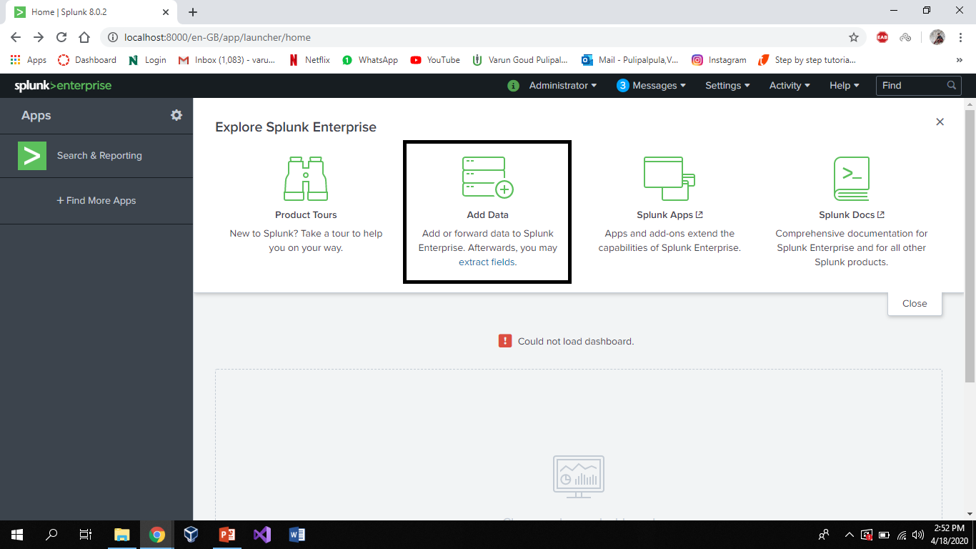

STEP2: Next click on “upload files from computer” as shown below.

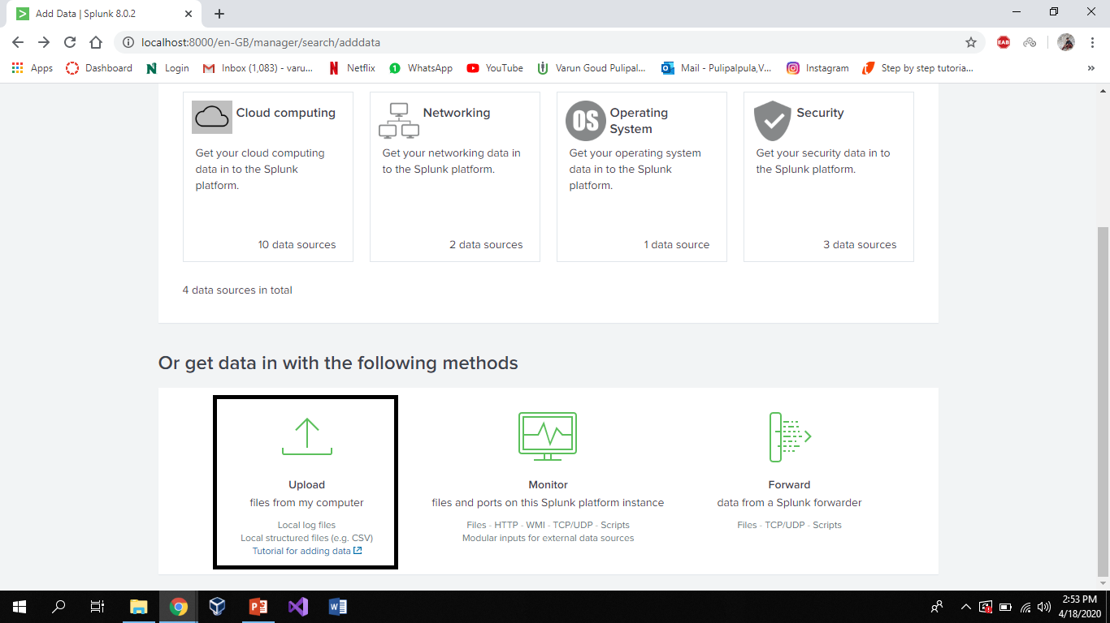

STEP 3: Next click on “Select File” to upload a file from your computer as shown below.

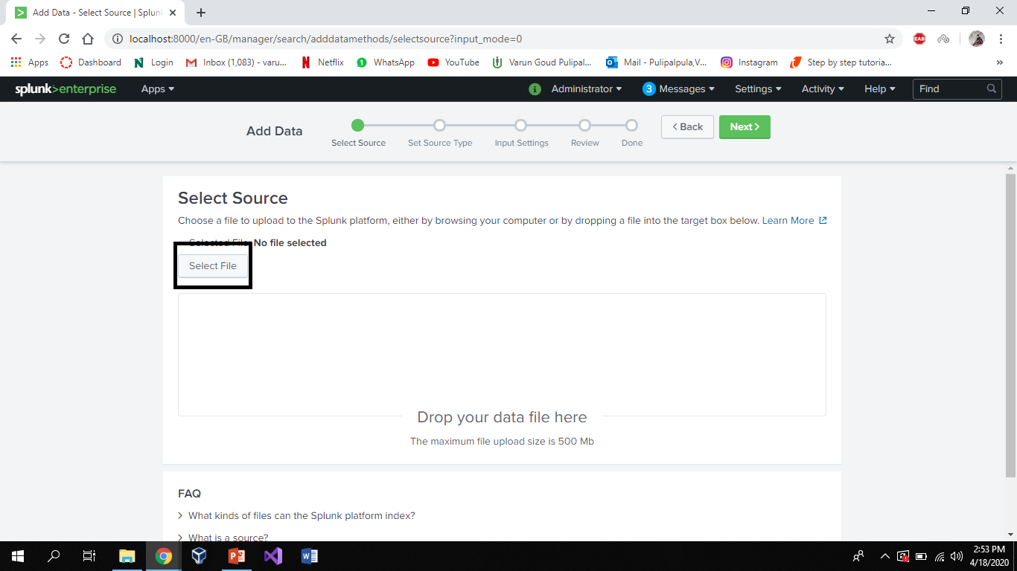

STEP 4: Check whether the file is uploaded or not, if uploaded then click on “Next” button as shown below.

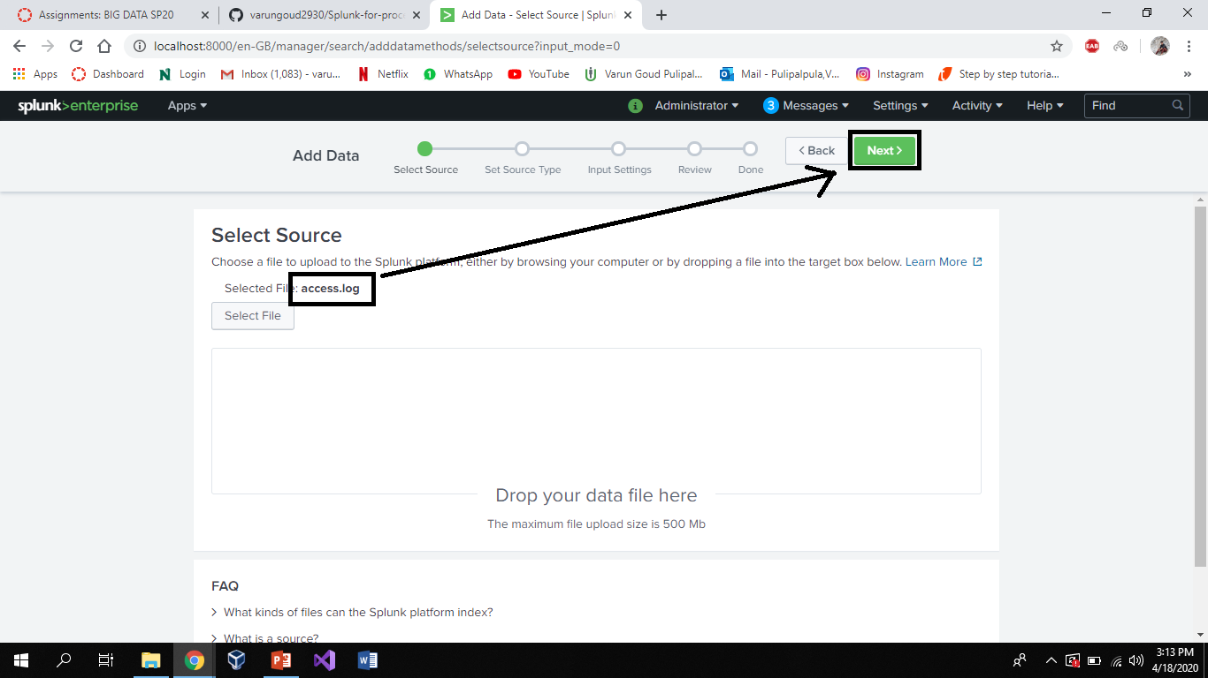

STEP 5: Next select the source type and click “Next” as shown in the boxes below.

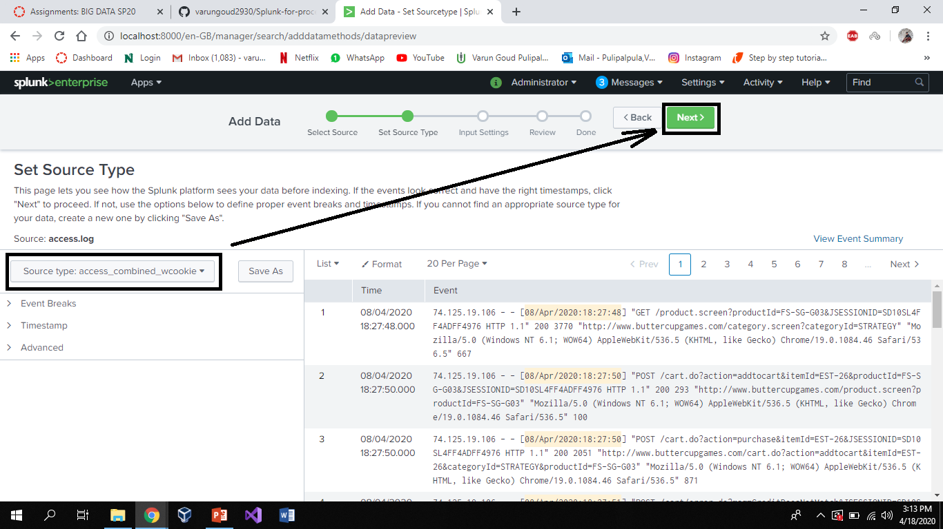

STEP 6: Next click on “Review” as shown below.

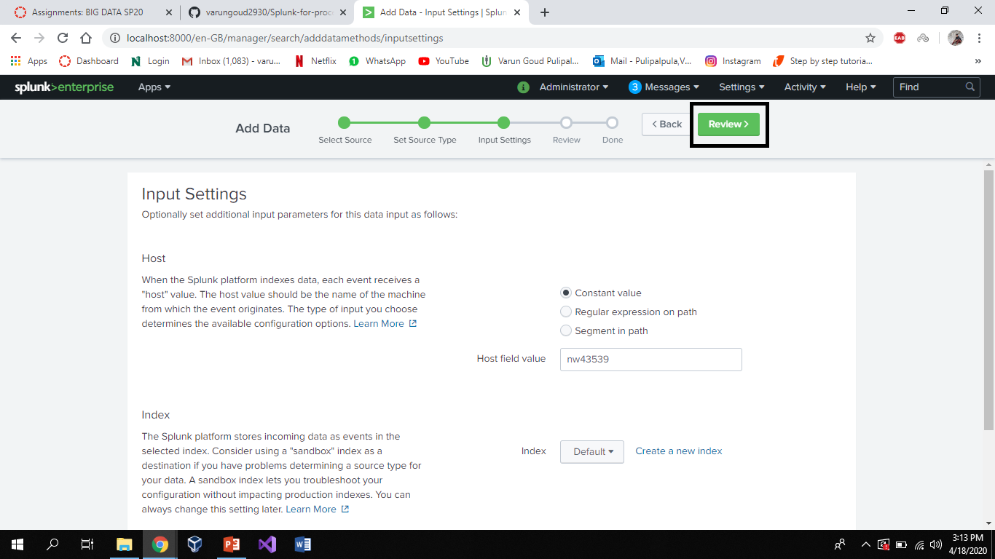

STEP 7: Check whether all the sources are correct or not, if all are correct then click on “Submit” as shown below.

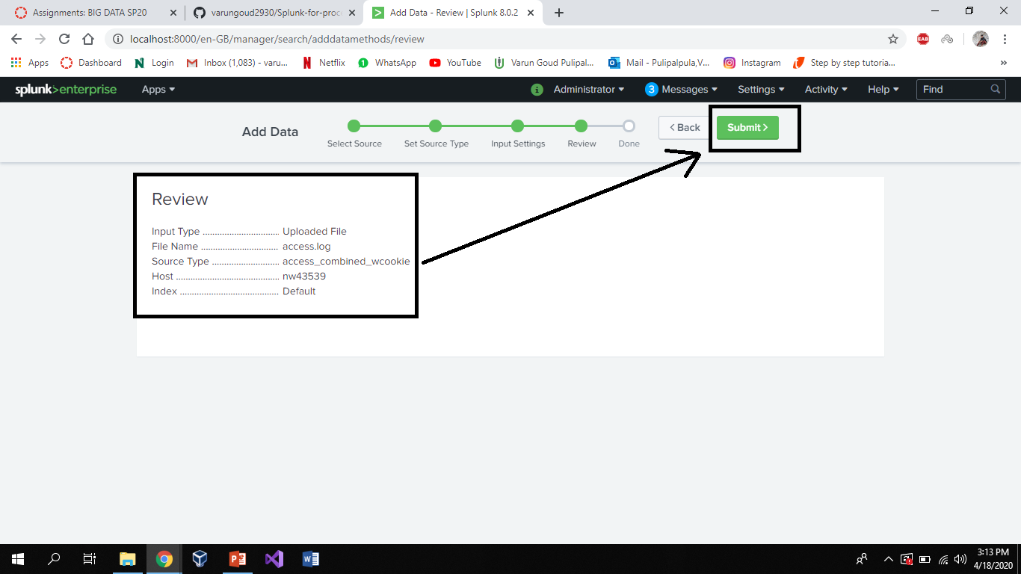

STEP 8: After clicking Submit then we should click on “Start Searching” to search events in our data as shown below.

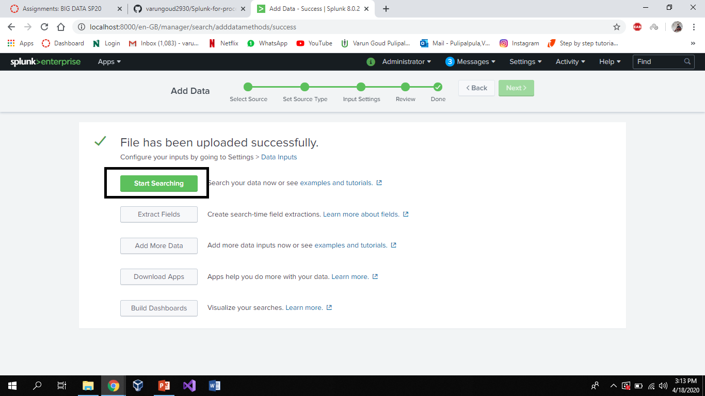

STEP 9: Then automatically in search box the data we given will be filled as in the box and we can see the number of events in the left small box. If you want a chart like pie chart or a bar graph etc. Then click on “Visualization” as shown below.

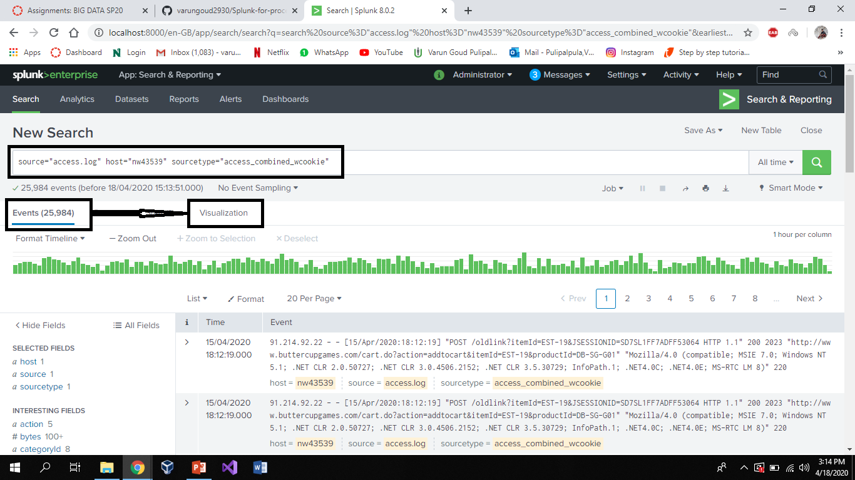

STEP 10: Here we can see a underlined because this data doesn’t have statistical data. When we upload data with statistics like population of cities in a country then we able to see the charts of our given data.

